Dear Mr. Moles

The Chilmark Selectmen voted and approved the expansion of Menemsha Pond private aquaculture area. There are currently six oyster farms and the approved expansion area would result in four additional farms. The Town of Chilmark would like to request permission from DMF to expand this area. Upon approval from DMF the Selectmen would like to request a dive survey to rule out any conflicts with native eelgrass and shellfish beds.

The Chilmark Board of Selectmen also approved another aquaculture area designated as offsite culling. This area would be available to all Chilmark oyster growers. This area is located along the Menemsha Channel in Menemsha Pond and shares the same growing area designation (V2). If approved by DMF, this area will be used for oyster seed growout through the use of a tidal upweller. This area will be used for seed growout and for landing product before selling. In order to keep future requests for designated upweller sites and potential conflicts with other pond usage to a minimum Chilmark designated this area. Having a central place for farmers to land shellfish and cull seed will aid Chilmark in enforcing compliance with the Vibrio Control Plan. With only three of the six farms currently selling adult oysters and the potential for additional four more upon approval Chilmark would like to be proactive for necessary infrastructure. Detailed plans for this equipment and location coordinates are provided with this letter.

Information provided with this request letter:

Expansion of Aquaculture Area

1. Map detailing the aquaculture expansion area of Menemsha Pond (Growing Area V2).
2. Tables that provide coordinates of the existing and proposed oyster grants/leases.
3. A letter from the Chilmark Board of Selectmen approving the expansion of this area.

Off Site Culling Area and Upweller Nursery Location

1. Map detailing the proposed offsite culling / upweller nursery area.
2. Tables that provide coordinates for the offsite culling area.

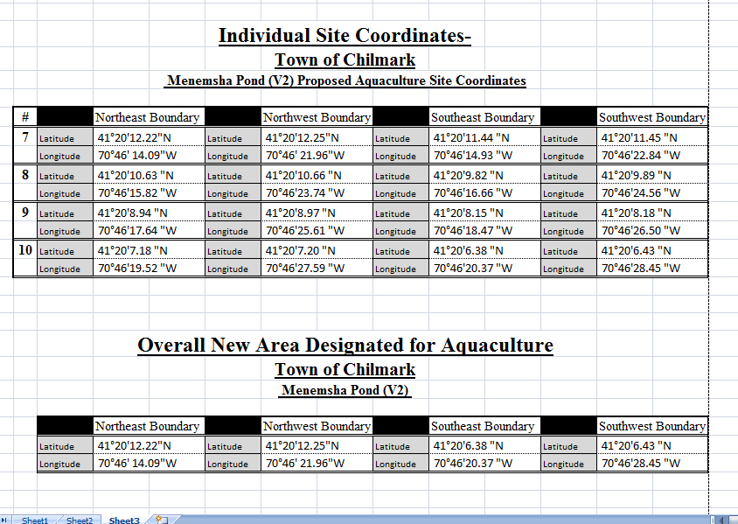

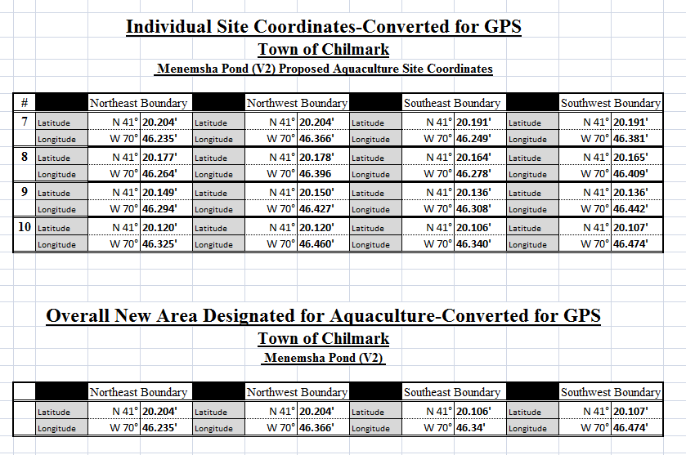

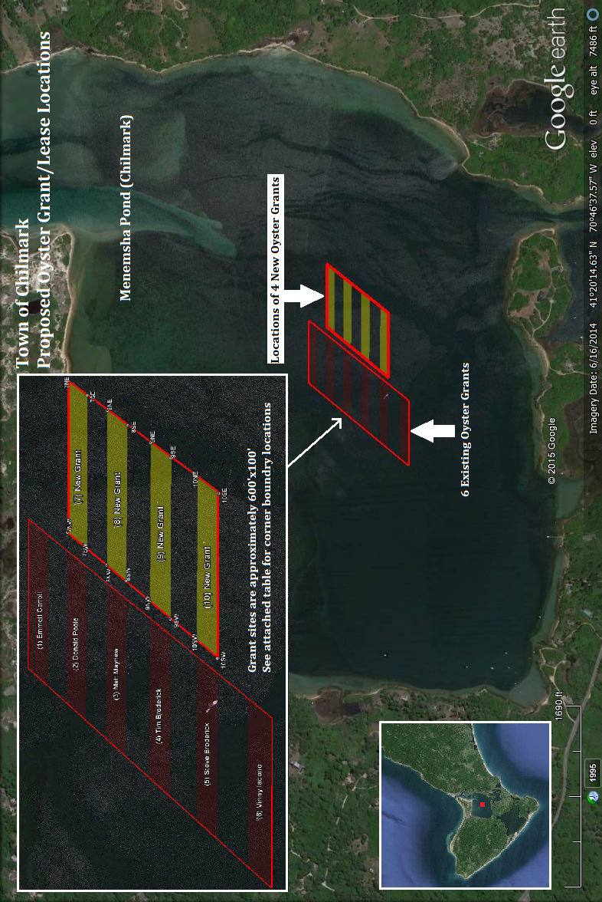

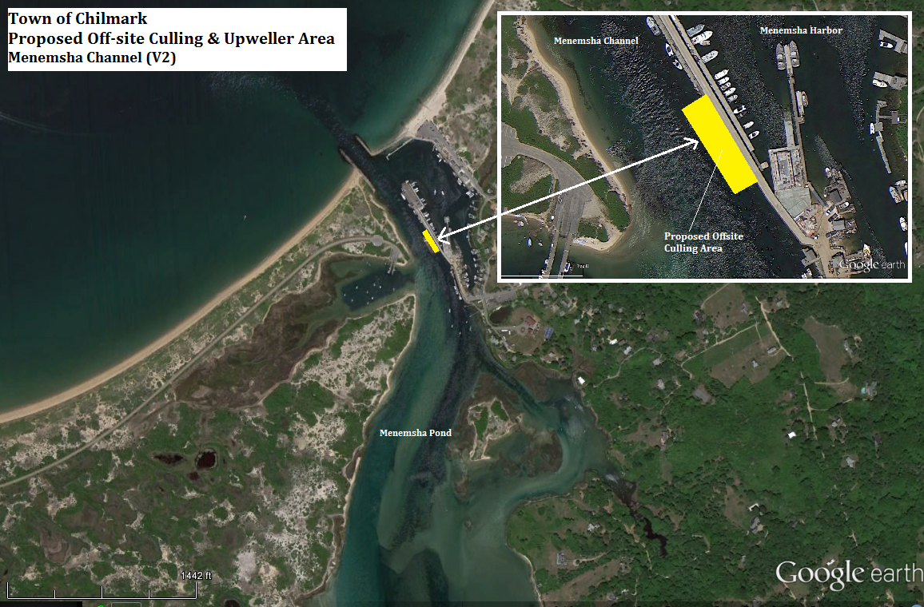

Oyster growers will only be able to use this area if they list it as off-site culling on their propagation permit from DMF.

